User Guide 9 Releasing for lodgment at Land Use Victoria
Purpose of this User Guide
The purpose of this User Guide is to provide guidance to Applicant Contacts and lodging parties about the SPEAR process of nominating a lodging party and a lodging method and how to release an application to the lodging party for the purpose of lodgment at Land Use Victoria. The lodging party is typically a solicitor or conveyancer acting for the applicant.
Who should read this?
Primary audience: Applicant Contacts and Lodging Parties
Introduction
Applicant Contacts are required to nominate the lodgment method – electronic or paper, for all Subdivision Act applications. This can be done once the application has been accepted by the Responsible Authority. If not completed earlier, it will be required before the application can be released for lodgment. For electronic lodgments, this action will allow the Applicant Contact to select the lodging party and grant them access to the SPEAR application. Alternatively, an electronic lodging party may request access and nomination in SPEAR.
The ‘Release for lodgement’ function in SPEAR will appear as a mandatory action for the Applicant Contact once all other requirements within that application have been met. It allows the Applicant Contact to deliver control of the application to the lodging party for lodgment at Land Use Victoria. An email notification can also be sent via SPEAR to inform the lodging party that the application is ready to be lodged.
Staff at Land Use Victoria will not be able to view the documents in SPEAR for lodging until the ‘Release for Lodgement’ action has been completed.
NOTE: Lodgment at Land Use Victoria may only occur when the Applicant Contact has released the application in SPEAR. Staff at Land Use Victoria will not be able to view the documents until this has occurred.
9.1 How does an Applicant Contact nominate the lodging method?
Only Subdivision Act dealing types require the lodgment method to be specified. Once the application has been accepted by the Responsible Authority, the optional action to ‘Nominate Lodgement Method’ will become available. If not completed prior to Statement of Compliance being issued, it will become a mandatory action. The application cannot be released for lodgment until the lodging method has been set.
It is recommended that Applicant Contacts first select lodgment via SPEAR and begin typing the name of the lodging party. If there are no matches then simply select paper.
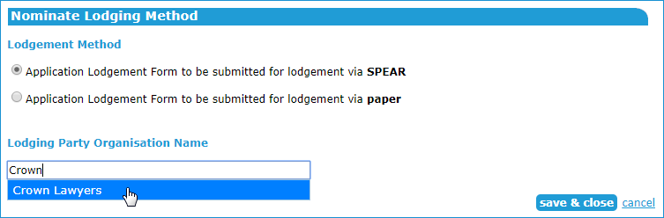

SPEAR will automatically email the lodging party when nominated.
Nominating an application to be lodged via SPEAR will give the electronic lodging party access to the SPEAR application, however they won’t be able to lodge the application with Land Use Victoria until the Applicant Contact has released the application.
9.2 How does a lodging party request access to an application?
An electronic lodging party may request access to an application once it has been submitted to the Responsible Authority. Select the action ‘Request lodging party access’ from the top-right of the Application List screen.
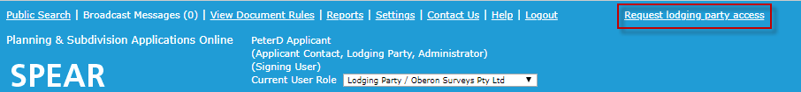
Enter the SPEAR reference number of the application and click ‘next’.
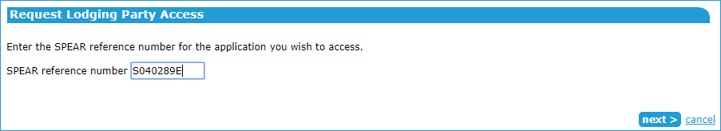
The property details will be displayed. If these are correct, click 'request access'. Otherwise, click the Search again hyperlink.
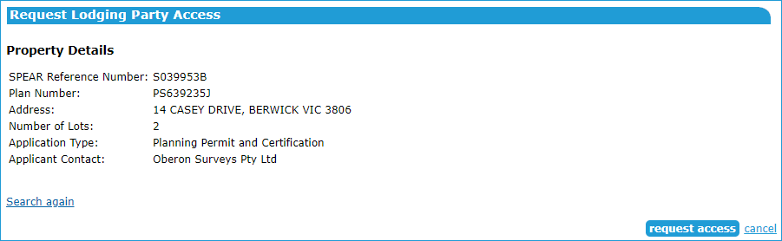
A request application confirmation will be displayed.
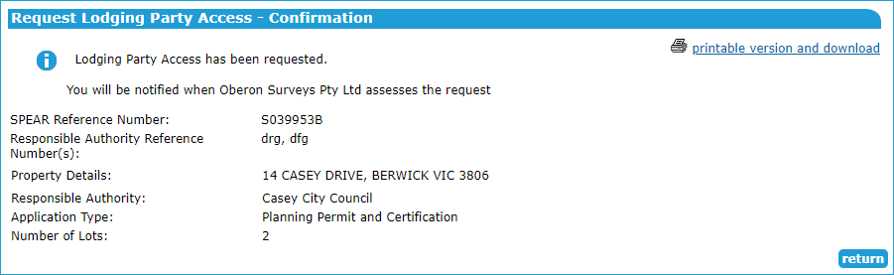
Click 'return' to the Application List.

9.3 How to respond to a lodging party access request
An Applicant Contact may receive a request to grant lodging party access to an application. To respond, click on the ‘Respond to Lodging Party Access Request’ action.
If you accept the request, SPEAR will automatically complete the ‘Nominate Lodging Method’ and nominate the application to be lodged electronically through SPEAR by that lodging party. If you reject the request, no changes to the ‘Nominate Lodging Method’ will occur.
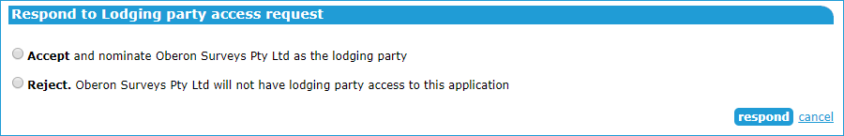
SPEAR will notify the lodging party whether the request has been accepted or rejected.
9.4 How does an Applicant Contact release an application?
Once all requirements within an application have been met, the application can be released for lodgment at Land Use Victoria.
For Subdivision Act applications, the release can occur once the Responsible Authority has certified the plan and issued Statement of Compliance (SOC). For all other applications requiring lodgment at Land Use Victoria, the Applicant Contact can release the application when all required documentation has been supplied.
After clicking the mandatory action to ‘Release for Lodgement’, select the checkbox under ‘to be released’ to release the application documents for lodgment.

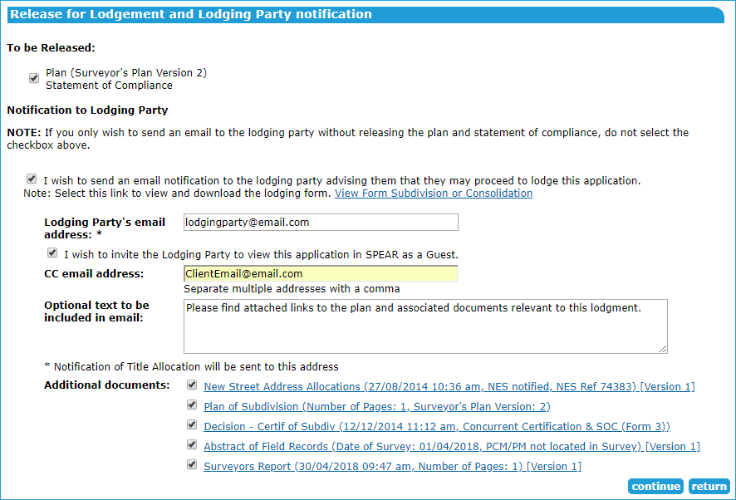

An email notification can also be sent to the lodging party and Applicant Contact may wish to invite the lodging party as a guest to view this SPEAR application.
Documents may also be attached to the email notification for the benefit of the lodging party. These are for information only; the original files will be extracted from SPEAR by Land Use Victoria staff.
If the application has been nominated for electronic lodgment and the lodging party selected, the Release for Lodgement screen will automatically complete the lodging party email address. The Applicant Contact may still copy in other interested parties, write an optional message, and select which document links to send to the additional email recipients.
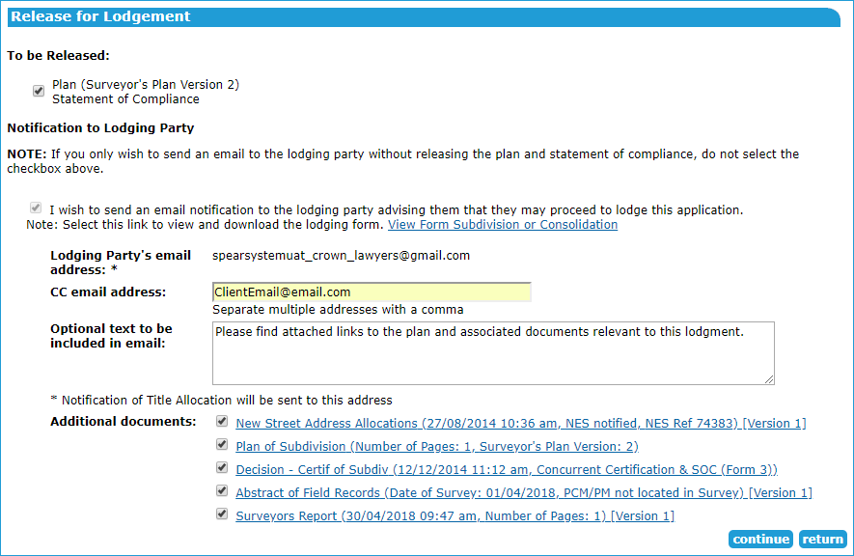
The ‘Release for Lodgement’ will need to be password authenticated from the Details tab before the application can be lodged at Land Use Victoria.
9.5 How does an Applicant Contact cancel a released application?
Once an application has been released, the Applicant Contact can cancel the release by selecting ‘Cancel a Release for Lodgement’ via the optional action drop-down list.
NOTE: If you have provided the lodging party’s email address a notification will be sent from SPEAR informing them of the cancellation.
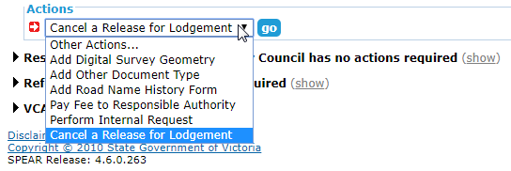

9.6 Do re-certified plans have to be released too?
Yes. The process for releasing a recertified plan and SOC is the same as for certified plans and must be repeated for each re-certification.
9.7 What happens once a SPEAR application has been released?
Once a SPEAR application has been released, the lodging party will lodge the application with Land Use Victoria. This may be an electronic lodgment submitted via SPEAR, or physical lodgment by attendance at Land Use Victoria with the required paper documentation for registration purposes.
The status of the application is updated in SPEAR as it progresses through Land Use Victoria.
Need more information?
Further information on this topic can be found by:
- Visiting the SPEAR website www.spear.land.vic.gov.au/SPEAR.
- Contacting the SPEAR Service Desk on 9194 0612 or email spear.info@delwp.vic.gov.au
- Selecting the Help link in the relevant area of the system.

